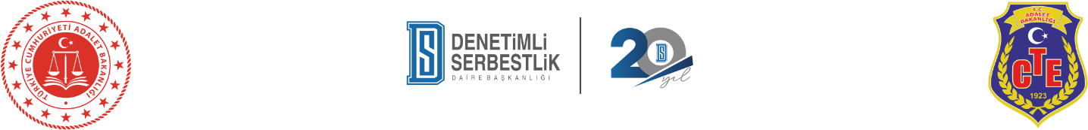

**International Congress on the 20th Anniversary of the Turkish Probation System**

**WORKSHOP APPLICATION FORM**

**WORKSHOP FACILITATOR / INSTRUCTOR DETAILS**

* **Workshop Instructor Email Address :**
* **Name :**
* **Surname :**
* **Phone Number :**
* **City :**
* **Country :**
* **Job Title :**
* **Agency / Organisation :**
* **ORCID Number :**
* **Professional Biography:** (1-2 paragraph, max of 100 words):
* **Your Photo:** The file must be in JPG, JPEG, or PNG format, with dimensions of 1920x1080 pixels, and a file size less than 25 MB. Please use the space below to upload your photo.
* **If applicable, please provide a brief summary of your prior workshop and training experience.**

**WORKSHOP DETAILS**

* **Workshop Language :** Turkish ( ) English ( )

**Please indicate your preferred presentation duration. Kindly note that the final decision regarding the presentation format will be made by the Organizing Committee.**

**Note: As workshop sessions are primarily scheduled for 60 minutes within the program, requests for longer sessions may not be accommodated.**

**( )** 30 min

**( )** 45 min

**( )** 60 min

**( )** 90 min

* **Number of Participants :** Minimum ( ) Maximum ( )

**Note: Workshop sessions are limited to a maximum of 50 participants. Requests for sessions exceeding this number may not be accommodated.**

* **Title of Workshop**
* **Workshop Content: (Please provide a detailed description of your workshop, including its subject, purpose, goals, methods, and expected learning outcomes. The description should be between 300 and 800 words)**.

**Please provide some topics related to your workshop.**

**( )** Rehabilitation and Reintegration

**( )** Post-Release Support Mechanisms

**( )** Combating Addiction

**( )** Juvenile Justice System

**( )** Digitalization

**( )** Probation Personnel Regime

**( )** Interagency / Institutional Collaboration

**( )** Voluntary Work

**( )** Public Perception in the Media

**( )** Vulnerable Groups (Women, Persons with Disabilities, Elderly, Foreigners)

**( )** Future Projections

**( )** Restorative Justice

**( )** Spiritual Guidance

**( )** International Approaches

**( )** Other:

**Please indicate the World regions mentioned in your presentation.**

**( )** Türkiye

**( )** Africa

**( )** Asia

**( )** Australia

**( )** Europe

**( )** North America

**( )** Latin America

**( )** Middle East